**Lab Objectives**

* Simulation using Excel
* Introduction to Crystal Ball

**Exercise # 1:** Manual Simulation

An emergency room at a nearby hospital has an average of 2 patients arriving every hour (exponentially distributed). Upon entering, each patient fills out a form; this always takes 5 minutes. Then, each patient is processed by one of two registration clerks. This takes an average of 7 minutes (exponentially distributed). Then each patient walks 2 minutes to a waiting room and waits to meet the doctor. The time it takes the doctor to see a patient averages 20 minutes with a standard deviation of 10 minutes (normally distributed).

1. Open a new sheet, name it “Emergency Room” and simulate the model for 100 patients.
2. After building the model, find the following:
   1. On average, how long does a patient spend in the emergency room?
   2. The maximum time spent waiting for a doctor.
   3. The maximum time spent waiting for a registration clerk.
   4. What percentage of time was registration clerk 2 idle?

**Hint for Random Number Generation:**

* From the Data tab choose Data Analysis
* Then choose Random Number Generation and press OK.
* Choose the distribution you want from the drop down menu
* Enter the distribution parameters (for example: if you chose Uniform distribution, enter the lower and upper limits)

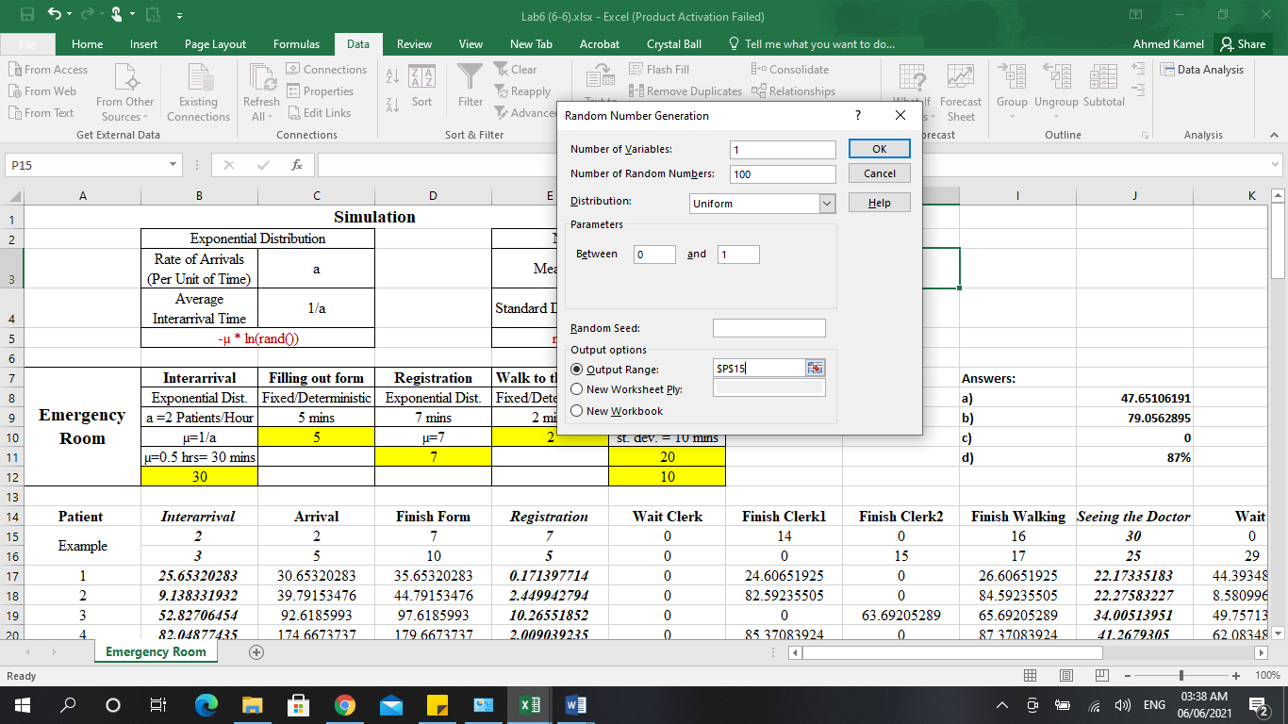

**Exercise # 2:** In a new sheet, solve the following problem:

You are facing an important decision: which monthly cell phone plan to subscribe to. You have selected two plans, one from Vodafone and one from Orange, but each offers different benefits. Both cell phone plans have their strengths and weaknesses, as follows:   
Vodafone:

* Pros: 400 minutes per month, no extra charges for long distance calls
* Cons: Every minute over 400 is an extra $0.40

Orange:

* Pros: Unlimited minutes
* Cons: Long distance charges are $0.08 per minute

Given the following data about the each plan:

|  |  |  |
| --- | --- | --- |
|  | **Vodafone** | **Orange** |
| Base Fee | $39.99 | $35.00 |
| Included Minutes | 400 | Unlimited |
| Additional Minutes | $0.40 | $0 |
| Long Distance | $0 | $0.08 |
| **Total Cost** | $ ? | $ ? |

To decide which plan is best for you, you need to calculate the total cost of each plan based on your usage. Assume that your usage is:

* Actual Minutes: 400
* % Long Distance (LD) Minutes: 30%
* No. LD Minutes: ?

**Answer the following questions:**

1. Calculate the **Total Cost** for each plan and **the No. of LD minutes** you expect to make.
2. If you choose the plan provided by Vodafone, how much do you expect to save?
3. Assuming that the **Actual Minutes** you will make is random and follows a normal distribution (mean = 400, St.dev. = 20), and the **% of Long Distance Minutes** you make is also random and follows triangular distribution (Min=10%, Likeliest=30%, Max=40%). Which plan is more cost effective?
4. Create a representable report.